**ITC 755**

**FINAL ASSIGNMENT (Analyze *Consumer information in relation to Sales & Profits*.)**

Study the provided 2 data files and join them in Tableau. After properly joined the dataset your team finish the following tasks:

**Task1: grouping customers.**

Try out the ways of grouping customers such as by gender, location, household size, income level and any criteria that you think would be good to classify customers. Try 2 level groups such as location and income level.

Show groups and number of customers of each group.

This horizontal bar chart shows the household income across different states as mentioned in the question above.

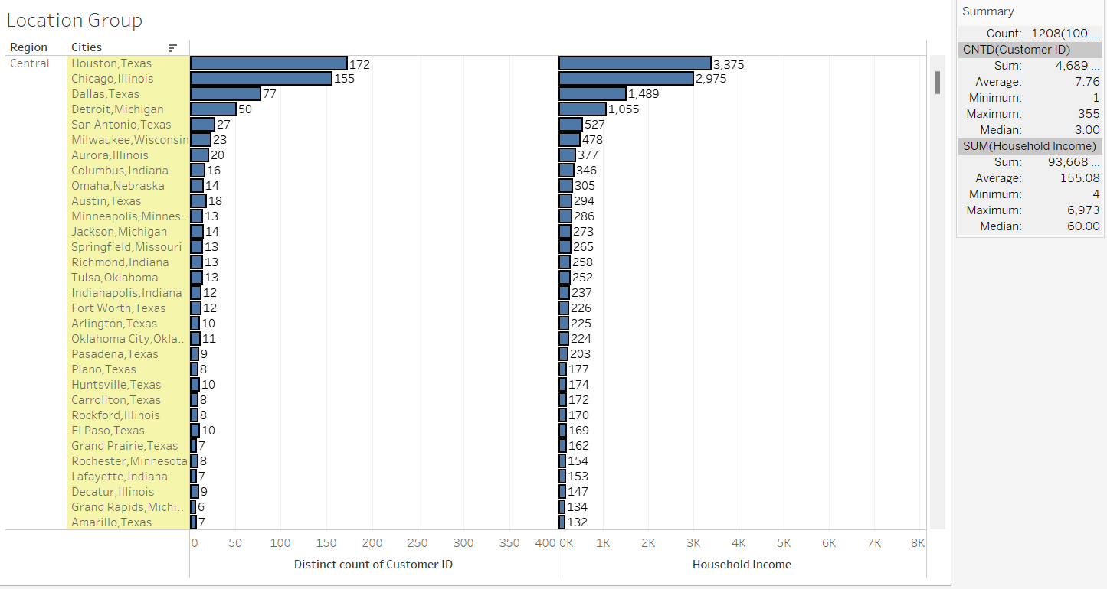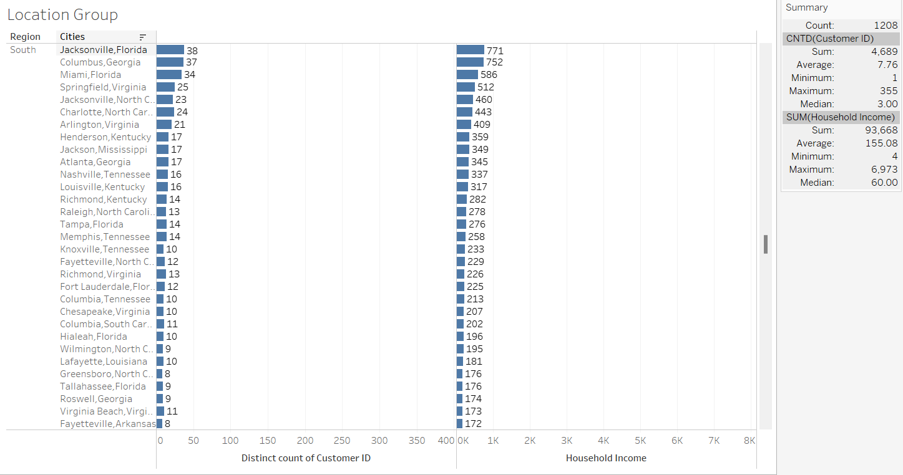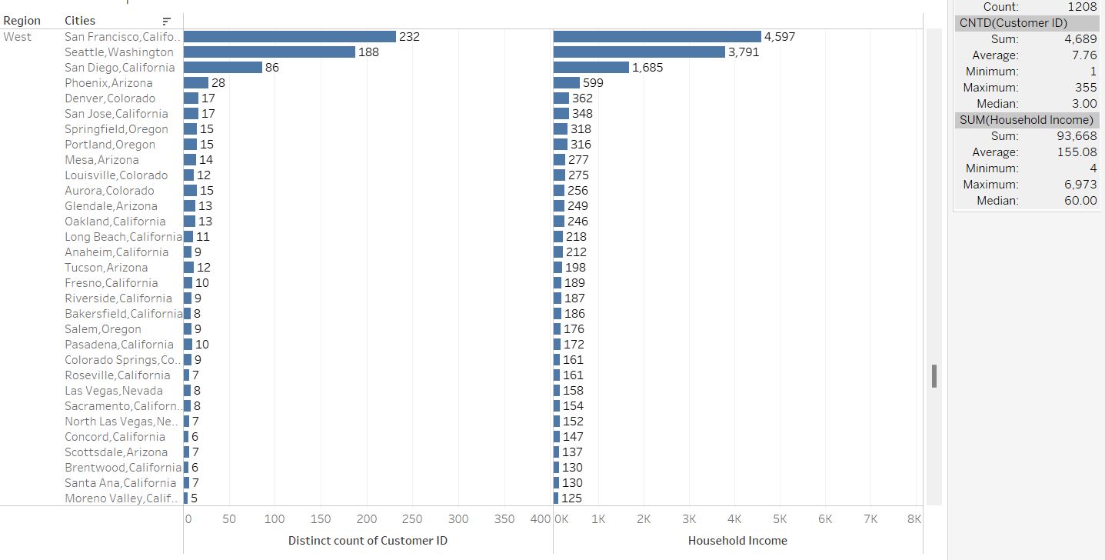

These horizontal bar charts show the number of customers and their household income across different regions (West, South, Central) in the US.

This chart shows how much each customer spent in each state.

This chart shows a gender-by-gender comparison of the household income in different family structures.

Here 1 = Under 25 years

2 = 25 – 29 years

3 = 30 – 34 years

4 = 35 – 39 years

5 = 40 – 44 years

6 = 45 – 49 years

7 = 50 – 54 years

8 = 55 – 64 years

9 = 65 + years

**Task2: customer segmentation.**

**Research on common methods of customer segmentation. What segmentation methods can be done on the given data? What** **can not? And why?**

Customer segmentation is a critical analytical process used in marketing to divide a customer base into groups of individuals that have similar characteristics. This process helps businesses tailor their strategies to specific groups, enhancing marketing effectiveness, customer service, and product development. Here are several common methods of customer segmentation that could be applied to the dataset you have:

1. **Demographic Segmentation:**

1. Age: Using birthdates to calculate age and grouping customers into categories like young adults, middle-aged adults, and seniors.
2. Gender: Segmentation based on male or female heads of households or the overall gender composition of the household.
3. Marital Status: Segmenting customers based on whether they are single, married, divorced, etc.
4. Education and Employment: Grouping customers based on the education level or employment status of the household's heads.

**2. Geographic Segmentation:**

Type of Residence: Analyzing customer location by the type of residence which could indicate urban, suburban, or rural habitats. Even if not explicitly mentioned, sometimes postal codes or regions can be inferred or added to segment by location.

**3. Behavioral Segmentation:**

Household Composition: Understanding customer behaviors based on the makeup of the household (e.g., presence of children, number of dependents).

Purchasing Behavior: If you integrate this data with purchase history, you could segment customers based on their buying patterns, product preferences, or spending habits.

Usage Rate: Segmenting customers based on their reported appliance and technology use (like TV items and internet connectivity) can indicate technology adoption rates or preferences.

**4. Value-Based Segmentation:** Segmenting customers based on their household income can help in understanding the potential revenue each segment could generate, allowing for strategies focused on high-value customers.

**The segmentation methods that cannot be done are:**

1. **Psychographic Segmentation:**

This involves segmenting customers based on lifestyles and personalities. While direct data might not be available in the dataset, inferences can be made based on household composition, education levels, and employment which might suggest certain lifestyle choices.

1. **Needs-Based Segmentation:**

Analyzing customer data to identify specific needs based on household size, presence of children, and employment status which can dictate varying needs for products and services. Again, the data for these are not available in the dataset.

**Q. Using Tableau to show 3+ examples of segmentation on the dataset.**

**For each customer segment, you can try to visualize the top 3 categories by average order quantity. And by average order value.**

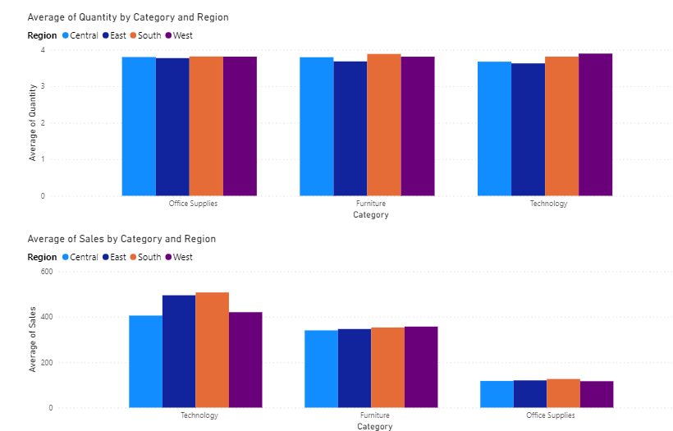

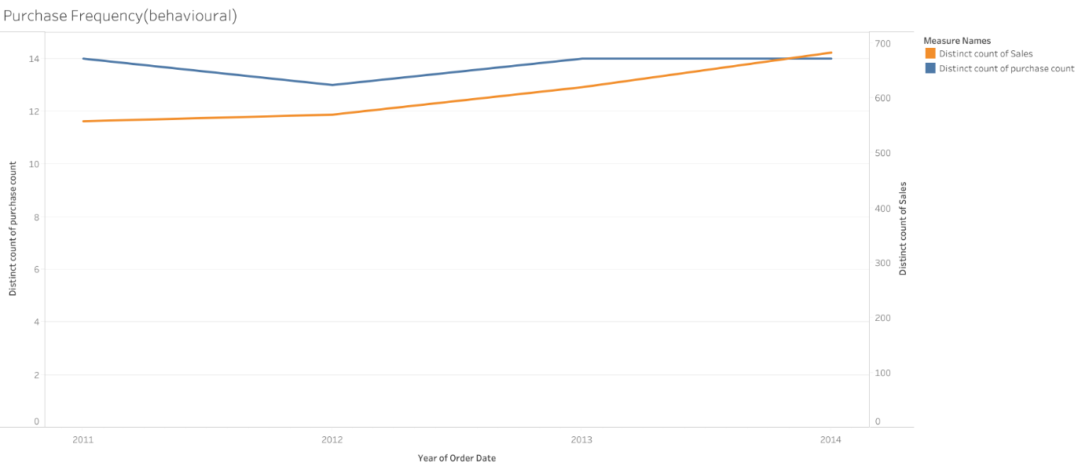

The chart above shows behavioral segmentation using purchase frequency. The purchase frequency was obtained by using the order ID and comparing it with the customer ID. Then we compared the purchase frequency with the sales frequency.

This data shows that the purchase count is trending downwards, however, the sales have been trending upwards, which could be the result of technological advancements.

**Tasks 3**. **Key products analysis:**

What are our key products that generate the most sales and profits? How has the demand been changing over the years, over states? Are there any emerging star products which sales have been increasing fast?

The bar chart above shows the highest-selling products across the US. The product that generates the most sales is Canon imageCLASS 2200 Advanced Copier. The number of sales generated = 61600

These are the sales trends of highest selling products from 2011 till 2014.

From the bar chart above, the product that generates the most profit is the Canon imageCLASS 2200 Advanced Copier. The amount of profit generated = 21200

These are the profit trends of highest selling products from 2011 till 2014.

This chart shows the demand for products across different states in the US.

**How do the key product sales and profits relate to the customer segmentation you did in task 1?**

In task 1 we classified customers based on gender, location, time, household income, and sales. We used visualizations like bar charts, and donut charts to show the trends of customer data. Whereas the question on task 3 indicates the product as the subject matter and uses metrics like sales and profits to show the differences across the data. There is one similarity though, in both instances, we use 2 pieces of data to highlight the subject matter, in this question the product and in 1, the customer. We use the second dependent variable (sales, profit, region) to classify the subject matter and find trends in data.

Requirements:

(1) Must design at least 1 table and 3 graphs for each of the 3 tasks above.

Must use tableau  
 Must be able to demonstrate it using tableau.   
 Reference to principles of Table/graph designs lectured in class (refer to PPTs)

(2) Format of your report: Should have a title page including authors, the normal text should use Times New Roman Font size 11, double space. The text is no less than 6 pages NOT including Tables and Graphs.

(3) Your report should focus on the business problems, not on the technical solutions.

(4) Your report must including the following sections

A. Executive summary

B. Customers structure *

* Your analysis: show your tables, visuals and your findings

* You results and conclusions: what suggestions you have for managers?

C. Customer Segmentation Analysis

* Your analysis: show your tables, visuals and your findings

* You results and conclusions: what suggestions you have for managers?

D. Key Products Analysis

* Your analysis: show your tables, visuals and your findings

* You results and conclusions: what suggestions you have for managers?

E. General conclusion and discussion

Discuss what your team have learned from analyzing the dataset.

Grading rubrics:

(1) Meet the requirements of contents and format

(2) Depth of analysis in the 3 business tasks. For example, have your team looked at a problem from different angles?

(3) whether your report is telling a good story.